

|  |
| --- |
| Project Title: Develop a SEO Tool to Analyze Live Web Pages |
| MATHIVARUNI RAJAKUMAR |
|  |

# Project Title: Develop a SEO Tool to Analyze Live Web Pages

Introduction:

Search Engine Optimization (SEO) is an important aspect of a Web page to gain importance for a search engine to be able to display it earlier in the search list. The optimization is based on a lot of factors such as title, description, header tags and keyword density. Different search engines will have their own mechanisms that calculate the score of a keyword on the page and thus work out its ranking in the search order.

Project Requirements

Python Version : python 3.x

Web Scraping Tool : BeatuifulSoup4

Database : SQLite

IDLE : PyCharm



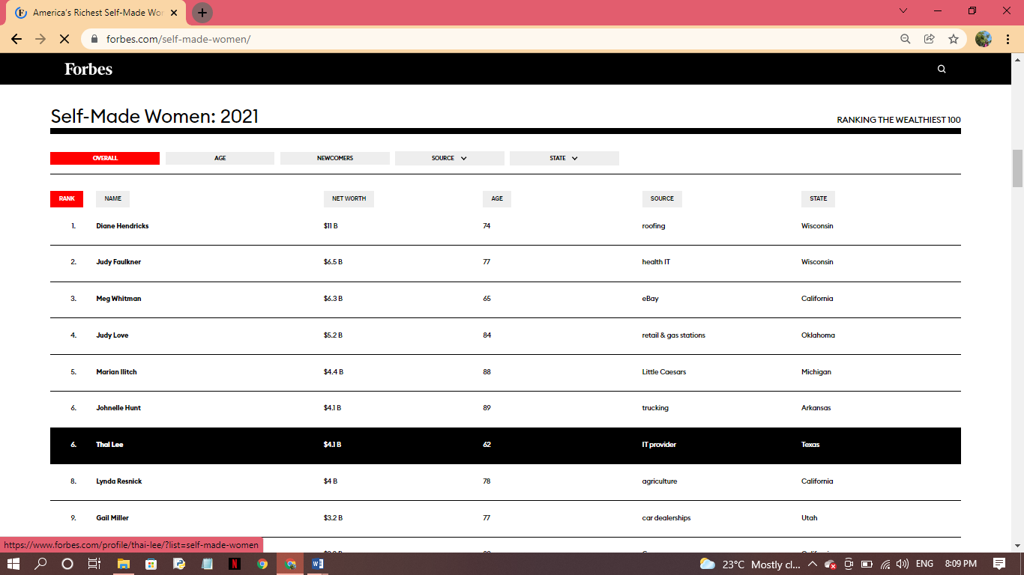

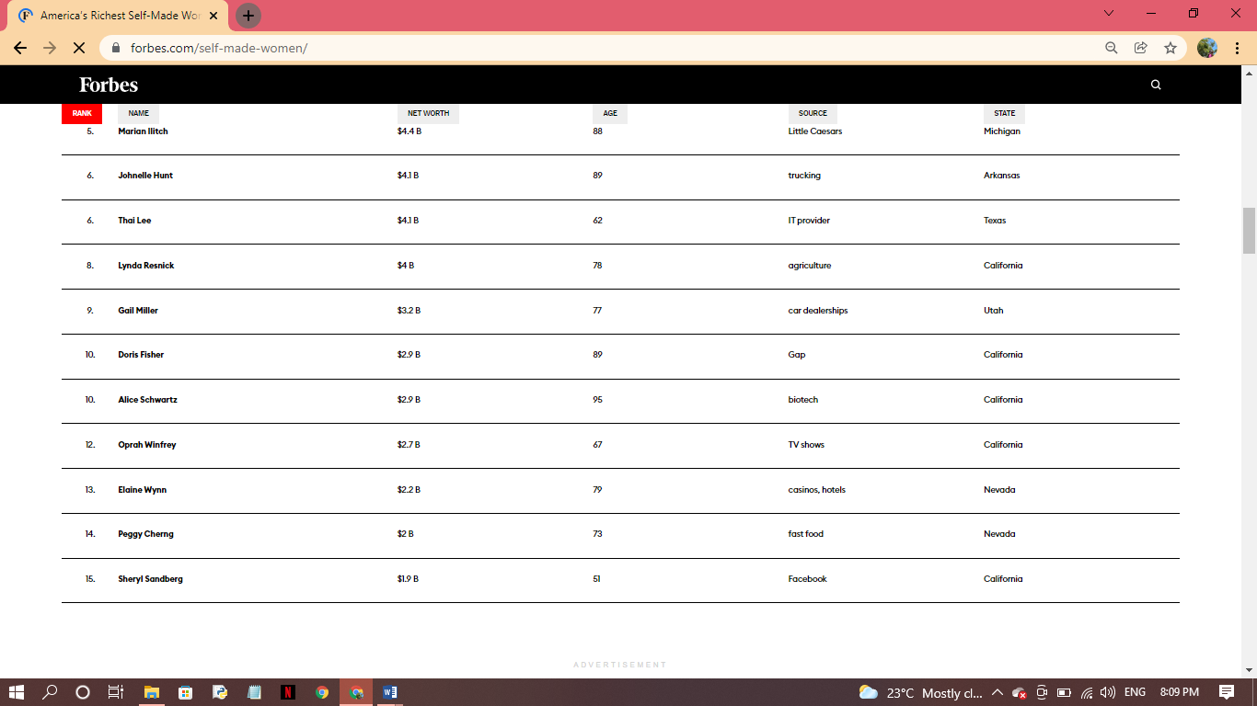

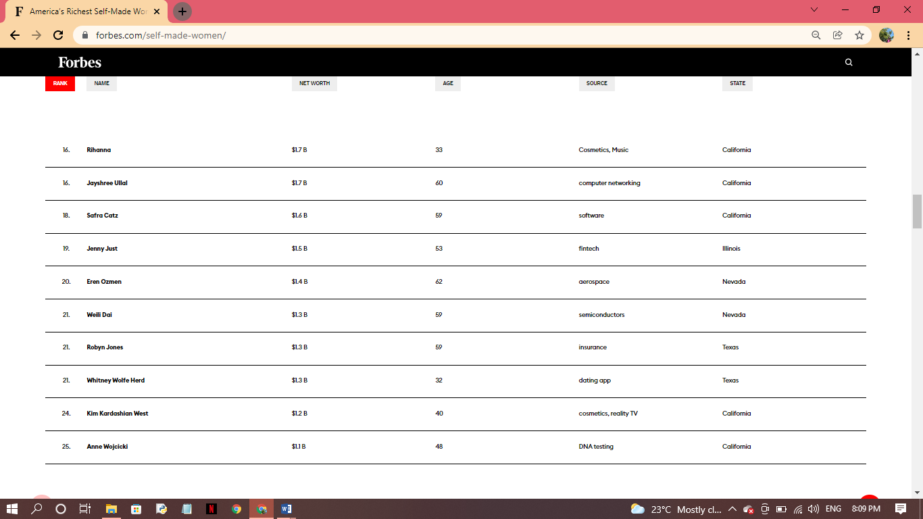

PROGRAM CODE:

import sqlite3  
from matplotlib import pyplot as plt  
import bs4  
import requests  
import json  
import xlsxwriter  
import xlrd  
  
  
  
class Webscrap:  
 final_data = []  
 read_data=[]  
 def data_extract(self,soup):  
 data = json.loads(str(soup))  
 data1 = data["personList"]["personsLists"]  
 # print(data1)  
 for dt in data1:  
 self.data_one = [  
 dt.get("rank", ''),  
 dt.get("personName", ''),  
 dt.get("finalWorth", ''),  
 dt.get("age", ''),  
 dt.get("source", ''),  
 dt.get("state", '')  
 ]  
 # print(data_one)  
 self.final_data.append(self.data_one)  
 # print(self.final_data)  
  
 def excel_data(self):  
 workbook=xlsxwriter.Workbook("Self_Made_Women_2021.xlsx")  
 worksheet=workbook.add_worksheet()  
 bold=workbook.add_format({'bold':True})  
 worksheet.write('A1','RANK',bold)  
 worksheet.write('B1','NAME',bold)  
 worksheet.write('C1','NET_WORTH',bold)  
 worksheet.write('D1','AGE',bold)  
 worksheet.write('E1','SOURCE',bold)  
 worksheet.write('F1','STATE',bold)  
 print("***********************************************")  
 print("EXCEL SHEET CREATED SUCCESSFULLY")  
 row=1  
 col=0  
 for data1 in self.final_data:  
 worksheet.write(row,col,data1[0])  
 worksheet.write(row,col+1,data1[1])  
 worksheet.write(row, col + 2, data1[2])  
 worksheet.write(row, col + 3, data1[3])  
 worksheet.write(row, col + 4, data1[4])  
 worksheet.write(row, col + 5, data1[5])  
  
 row+=1  
 print("*******************************************")  
 print("DATA PRINTED SUCCESSFULLY")  
  
 chart1=workbook.add_chart({'type':'column'})  
 chart1.add_series({'categories':'=Sheet1!$B$2:$B$50','values':'=Sheet1!$C$2:$C$50'})  
 #chart1.add_series({'categories':'=Sheet1!$B$2:$B$50','values':'=Sheet1!$C$2:$C$50'})  
 chart1.set_title({'name':'Self made Women:2021'})  
 worksheet.insert_chart('K4',chart1)  
 workbook.close()  
 print("*********************************************")  
 print("GRAPH OF THE DATA SUCCESSFULLY DRAWN ON EXCEL SHEET")  
  
 def read_excel(self):  
 wb=xlrd.open_workbook("Self_Made_Women_2021.xlsx")  
 worksheet= wb.sheet_by_name("Sheet1")  
 num_rows=worksheet.nrows  
 num_cols=worksheet.ncols  
  
 for current_row in range(0,num_rows,1):  
 row_review=[]  
 for current_col in range(0,num_cols,1):  
 review=worksheet.cell_value(current_row,current_col)  
 row_review.append(review)  
 self.read_data.append(row_review)  
 #print(self.read_data)  
 print("***********************************************")  
 print("DATA READ FROM EXCEL AND STORED SUCCESSFULLY...!!!")  
  
 def data_base(self):  
 db_values=self.read_data  
 con=sqlite3.connect("SELF_MADE_WOMEN_2021.db")  
 print("*********************************")  
 print("DATABASE CONNECTED SUCCESSFULLY..!!!")  
 cur=con.cursor()  
 listofTables=cur.execute("""SELECT 'SELF_MADE_WOMEN_2021' FROM sqlite_master WHERE type='table'""").fetchall()  
  
 if listofTables==[]:  
 cur.execute('''CREATE TABLE SELF_MADE_WOMEN_2021(  
 Rank INTEGER NOT NULL,  
 Person_name TEXT,  
 Net_worth INTEGER NOT NULL,  
 Age INTEGER NOT NULL,  
 Source TEXT,  
 State TEXT);''')  
  
 else:  
 print('Table found!!')  
  
 #print(db_values)  
  
 cur.executemany("INSERT INTO SELF_MADE_WOMEN_2021(Rank,Person_name,Net_worth,Age,Source,State) VALUES(?,?,?,?,?,?)",db_values)  
 con.commit()  
 print("*****************************")  
 print("DATA STORED IN DATABASE SUCCESSFULLY!!")  
  
 def graph(self):  
 first_plot=[dt[1] for dt in self.final_data]  
 second_plot=[dt[2] for dt in self.final_data]  
 #print(first_plot)  
 #print(second_plot)  
 plt.bar(first_plot,second_plot,color='r')  
 plt.legend(["NAMES","NET_WORTH"])  
 plt.show()  
 print("********************************")  
 print("BAR GRAPH DRAWN SUCCESSFULLY...!!")  
  
 plt.scatter(first_plot,second_plot,label='cases',color='r')  
 plt.show()  
 print("********************************")  
 print("SCATTER GRAPH DRAWN SUCCESSFULLY...!!")  
  
  
  
  
  
urllink="https://www.forbes.com/forbesapi/person/self-made-women/2021/position/true.json"  
header={  
'User-Agent':'Mozilla/5.0 (Windows NT 10.0; Win64; x64) AppleWebKit/537.36 (KHTML, like Gecko) Chrome/95.0.4638.69 Safari/537.36'  
}  
  
response=requests.get(url=urllink,headers=header)  
soup=bs4.BeautifulSoup(response.content,"html.parser")  
#print(soup.prettify())  
w=Webscrap()  
w.data_extract(soup)  
w.excel_data()  
w.read_excel()  
w.data_base()  
w.graph()

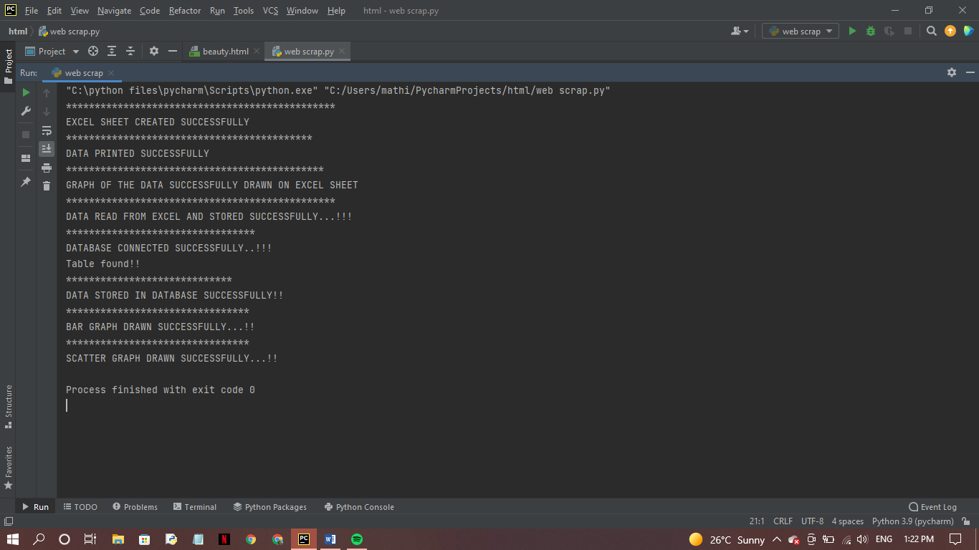OUTPUT:

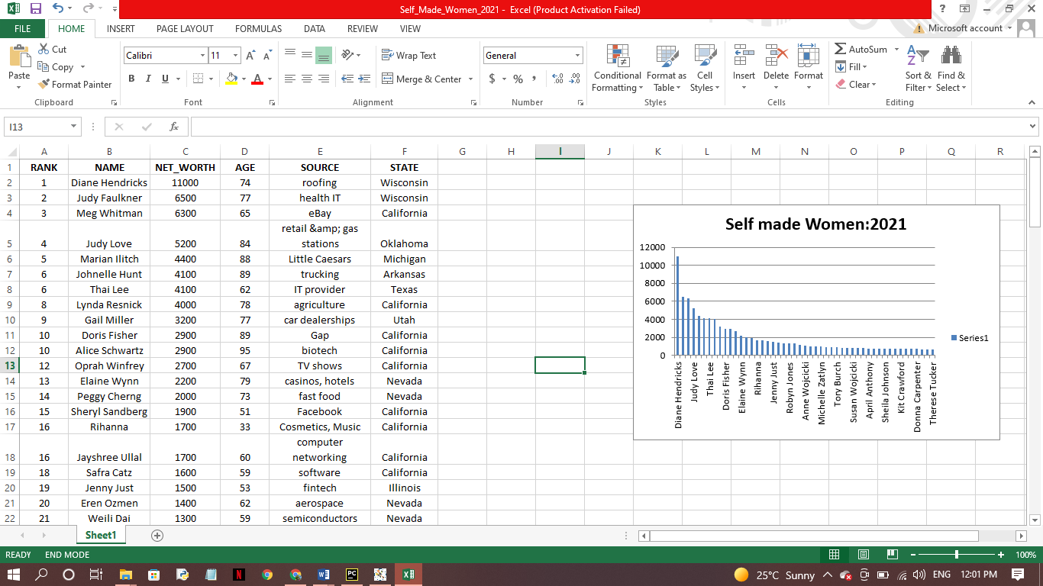EXCEL SHEET OF ALL DATAS:

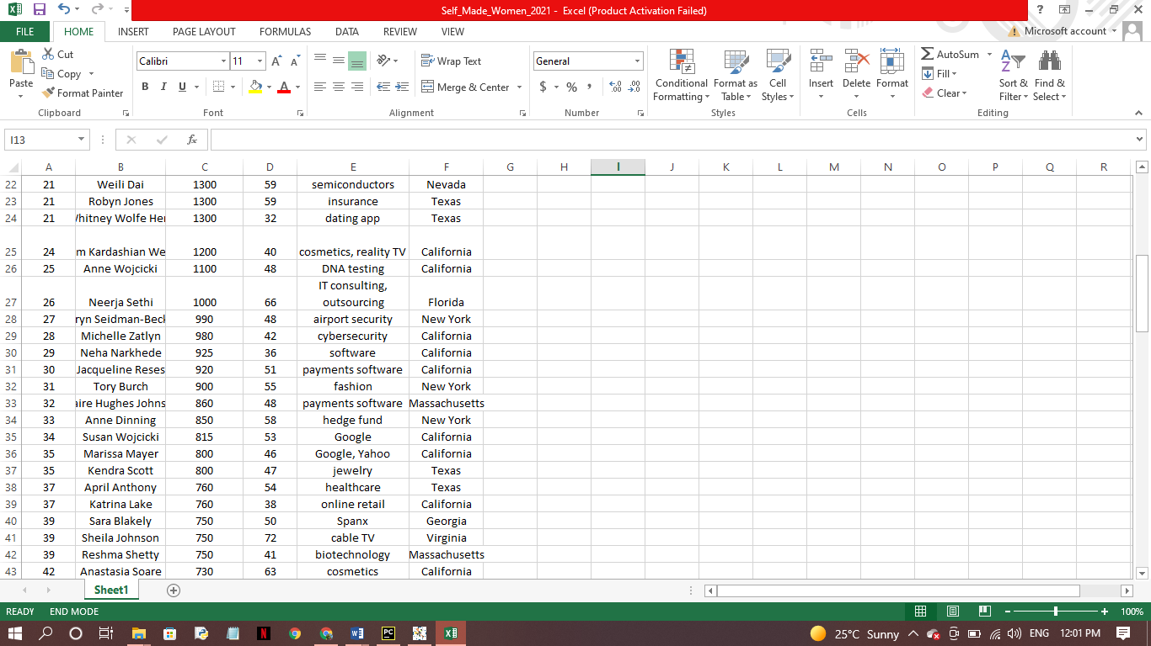

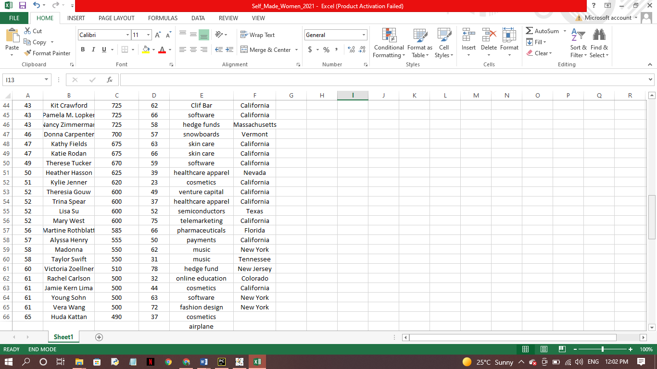

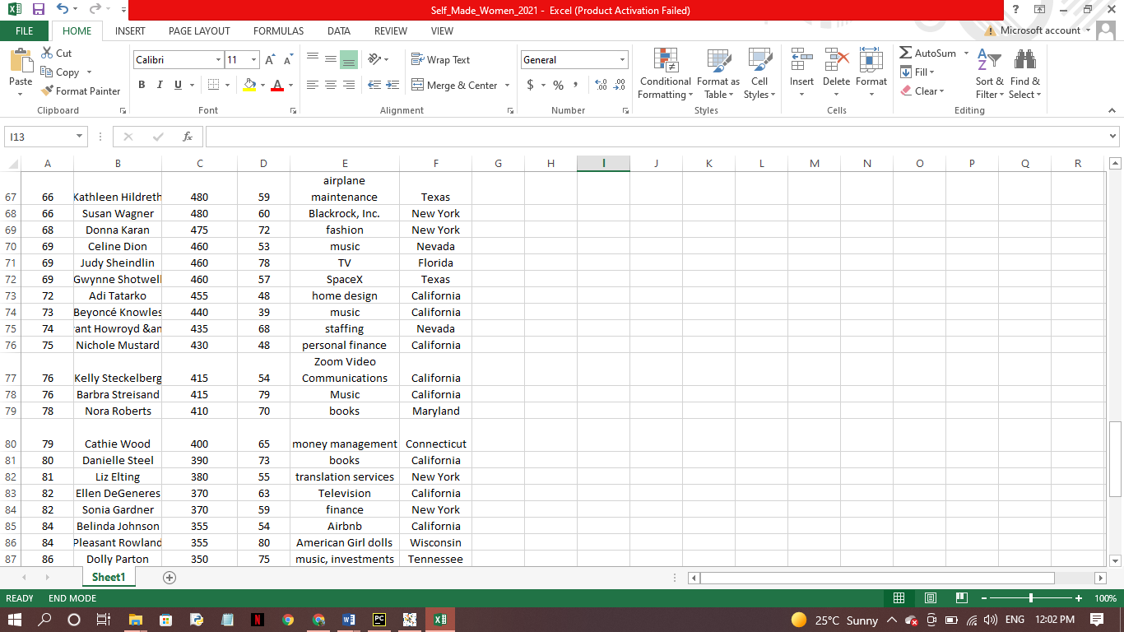

BAR GRAPH OF THE WOMEN AND THEIR NET WORTH:

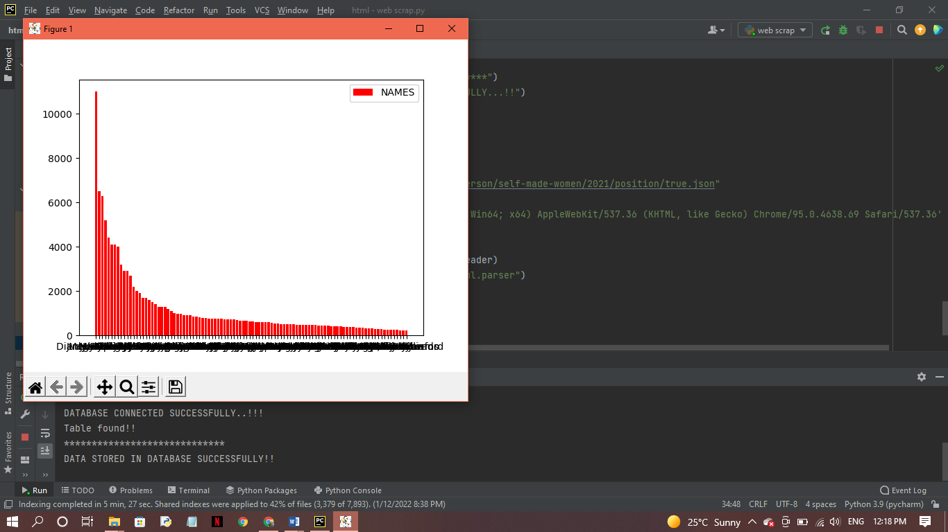

SCATTER PLOT OF THE WOMEN AND THEIR NET WORTH:

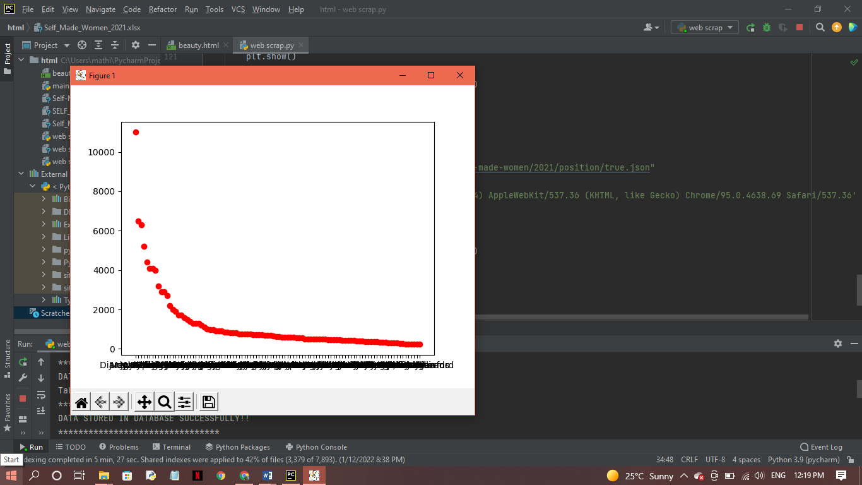

EXCEL GRAPH:



